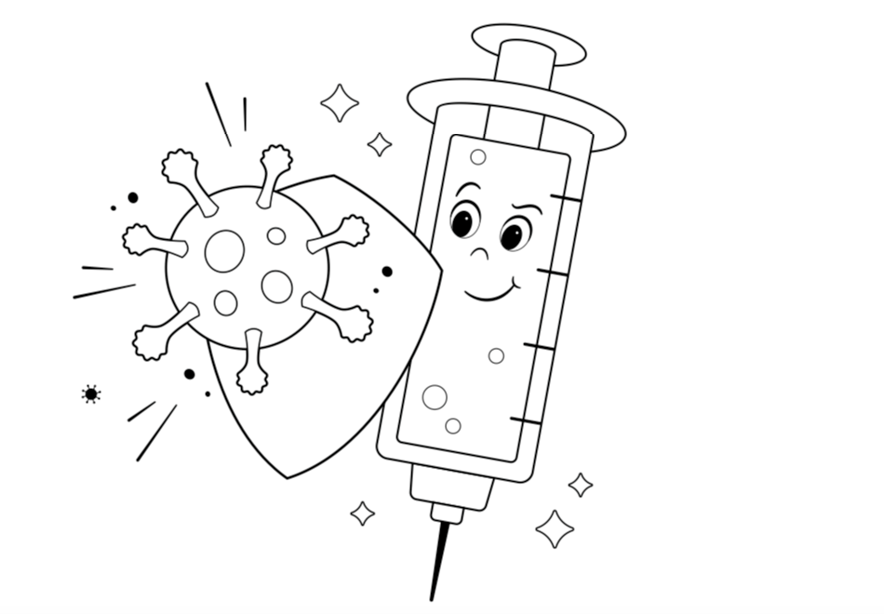

Can you help the vaccine through the maze to vaccinate the children?

START

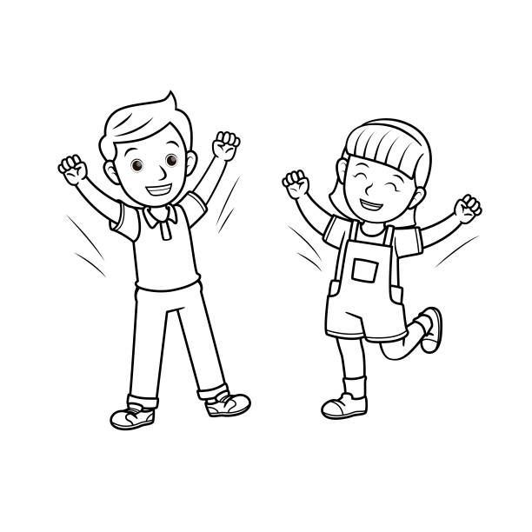

Finish

Solution:

Image credits:

<https://i0.wp.com/www.wktvjournal.org/wp-content/uploads/2021/11/Screen-Shot-2021-11-02-at-10.40.15-AM.png?ssl=1>

<https://www.istockphoto.com/vector/a-couple-of-children-feeling-happy-raise-arms-to-the-air-for-emotion-face-gm1296612814-389985046>