- When meningococcal disease strikes, 10-15 % of those infected will die. Of those who survive, 11-19 % will live with permanent, calamitous and hugely expensive disabilities, such as brain damage, limb amputations, hearing loss, or loss of kidney function. Overall, 1 in 3 victims suffer catastrophic outcomes. Meningococcal meningitis is a relatively rare vaccine preventable disease (VPD), but a devastating one.
- Disease associated with Neisseria meningitidis bacteria includes meningitis (brain infection; 50% of cases), bacteremia (blood infection; 38% of cases), and bacteremic Pneumonia (lung infection with associated blood infection; 9% of cases). A hemorrhagic rash may lead to gangrene, requiring limb amputations.
- Transition from early mild, flu-like symptoms to critical, life-threatening infection is so rapid that death may occur before a correct diagnosis and appropriate treatment is fully established.
- This disease strikes unpredictably, among healthy individuals as well as in certain high risk groups. Most cases are isolated and sporadic rather than in outbreaks. Sporadic or initial outbreak cases cannot be prevented by antibiotic prophylaxis, though this has some utility to prevent secondary cases in outbreaks.
- By age, teenagers and young adults are the highest risk groups for illness from Meningococcal meningitis types A, C, Y and W, which cause ~73% of all cases in those > 11 years of age.
- Meningococcal type B illness accounts for ~ 1/3 of meningitis in teens and adults, and has been implicated in multiple college outbreaks. Disease characteristics are similar across all meningococcal meningitis types.
- Adolescents and young adults have the highest nasopharyngeal carriage rates, and are considered the key reservoir for transmission of Neisseria Meningitidis disease. Carriage rates are estimated at 12% by 15 years of age, 20% by 17 years, 23% by 18 years, and at a peak of 24% by 19 years old. There are slightly more male than female carriers.
- Overall, incidence among college students appears like that observed among persons of approximately the same age in the general population. However, multivariate analysis suggests that first-year college students living in residence halls are at higher risk for meningococcal disease than other students.
- Preceding upper respiratory viral/bacterial infections, crowded living conditions, high social mixing, both active and passive smoke exposure, excessive alcohol consumption, and sharing of secretions by kissing or sharing of drinking utensils are associated with increased risk for meningococcal disease.
- People with low socio-economic status, whatever their ethnic origin, are more likely to develop meningococcal disease. Certain chronic underlying illnesses (immune compromise, non-functioning or absent spleen, etc.) are also associated with increased risk.
- There are other, less severe causes of meningitis - viral meningitis is much more common, has similar initial symptoms, but does not typically result in severe outcomes. However, when possible meningitis cases are identified in group settings, school and public health officials must often immediately mount large manpower and economic intensive outbreak control measures before a complete diagnosis is available.

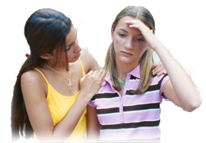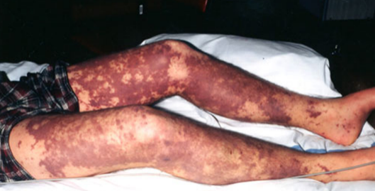
More information about meningococcal disease: www.cdc.gov/meningococcal/index.html

