IMMUNIZATION TASK FORCE METRO OMAHA | 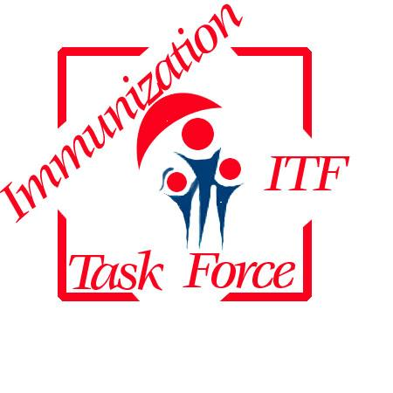
Steering Committee Minutes
Friday March 1, 2013
7:30-9:00 AM
MOMS Conference Room
Tower Professional Park, 7906 Davenport Street

Introductions

Members Present: Sharon Plummer, Michelle Hokanson, Jude Dean, Linda Ohri, Melanie Moore, Sharon Wade, Laura Klug, Pat O’Hanlon, Georganna Felt,

Members Absent: Patsy Nowatzke, Archana Chatterjee, Katie O’Keefe, Bridget Rolenc, John Pawlowski, Michael Owens, Jane McGinty, Vicki Sunderman, Cathy Carrico, Jim Arch

Announcements:

Jane McGinty will be participating in Project Homeless Connect on March 22 to give Tdap and Influenza immunizations, however, it anyone has additional vaccine to donate, esp. PPSV-23, they would be so grateful. If you know of resources, please contact Jane McGinty herself, or Laura Klug who will put you in contact with Jane. Thank you.

Minutes from the February 1, 2013 meeting; Minutes approved

Treasury Report

Debit on February 5, 2012 Walnut Plaque for outgoing Chair $55.00
Debit on February 12, 2013- Two tables for Black Family Health Fair $100.00
Balance $12,113.78

Committee Reports:

Community Affairs: (Chair-Vicki Sunderman)

No report from Chair

Jane and Pat continue to work with Charles Drew and the daycares to provide education and vaccination for daycare employees.

Pat and Bridget – maybe consider funds in the future for the purchase of a few intranasal influenza vaccines to have on hand for those very resistant to vaccination due to needle phobias.

Professional Affairs: (Chairs-Cathy Carrico and Katie O’Keefe)

No report from Chairs.

Annual Immunize Nebraska Conference scheduled for June 12th and 13th 2013. The CME brochure should be ready for distribution next week.

There will not be a NESIIS report at the conference this year.

The dinner program on the first night of the conference is still awaiting approval of a speaker. Details to follow

Legislative: (Chair-Linda Ohri)

Legislator Bob Krist has introduced the following 3 bills. They have all progressed into general record.

- LB458 Require general acute hospitals to offer tetanus-diphtheria-Pertussis vaccinations as prescribed Open hearing February 22, 2013

- LB459: Required certain health care facilities to offer onsite vaccination services. Open hearing February 22, 2013

- LB460: Require a booster meningococcal conjugate vaccine for students as prescribed. Meningococcal is not required now, this will be a school mandate.

Thank you to Linda for writing letters in support of LB458 and LB459

The Public Hearing on February 7, 2013 on establishing the State Immunization Registry as the formal repository for Immunization Records went through as there was no one there to testify against this.

Website: (Chair-Sharon Plummer)

The website is getting ready to go live. There are just a few details left to iron out with Chip Thompson. We hope to be live by April 1st 2013.

Sharon will be arranging a meeting with the website committee and the other committee chairs (or approved delegates) to meet with Chip Thompson and train on the WordPress software.

Other Business

Pat O’Hanlon presented an update on the Hepatitis B vaccination program. See attached report. Thank you to Pat for his continued efforts and great results with this program!

The availability of the quadrivalent flu vaccine with an additional B for ages 3 and over for the 2013-2014 influenza season was discussed. (added by Sharon Plummer)

Next meeting scheduled for April 5, 2013, from 7:30 to 9:00 AM at the Metro Omaha Medical Society (MOMS) office at 79th and Davenport.

Respectfully Submitted,

Laura Klug
Chair, Metro Omaha Immunization Task Force

